Hands-On

BI Story Tutorial Human Resources Employee Churn

Author: Herve KAUFFMANN

This guide will walk us through the process of Building a BI story based on the Output dataset generated when Applying the HR Predictive Scenario for employees at risk detection.

First log on to a SAP analytics Cloud instance.

Before we start, have a look at you profile setting and make sure the number formatting is set to “1,234.56”.

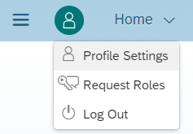

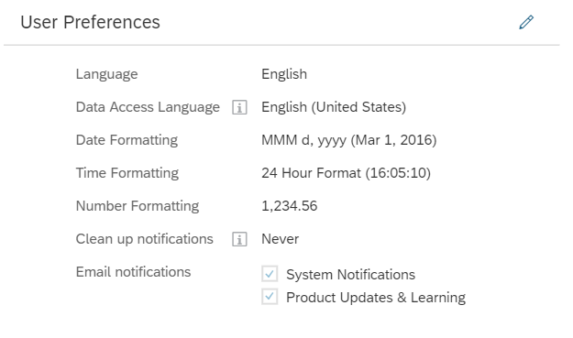

To create a new Story from an already existing BI Model, we click on the menu on the top left, select “Create” and click on “Story”.

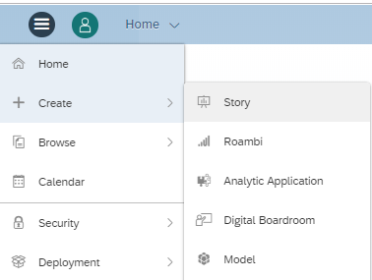

We select “Access & Explore Data”.

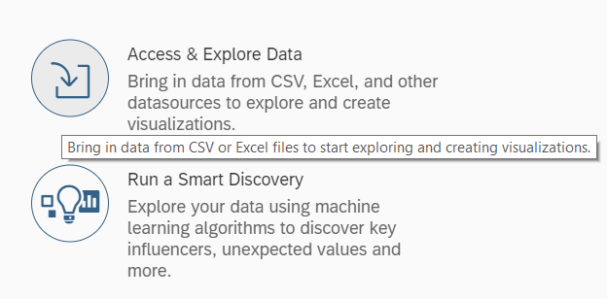

We select “Data Acquired from an existing model”, then we search for “EmployeeChurnResults” model

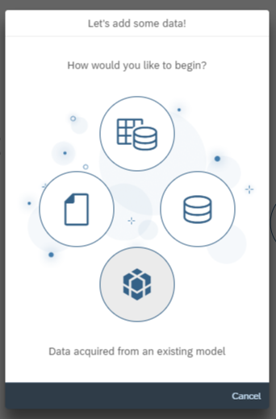 then 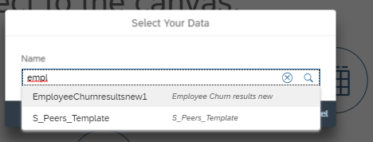

Now that we have uploaded the BI Model, we select Story, then “Chart”.

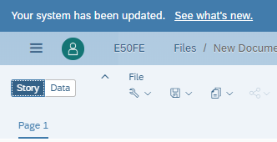 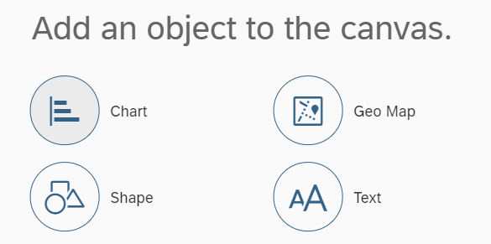

We start now the process to add a Bar / Column chart to expose the risk of churn per age. At the top right of the screen we select “Designer”, then we select “Comparison” and Bar/Column” in the in the Design panel.

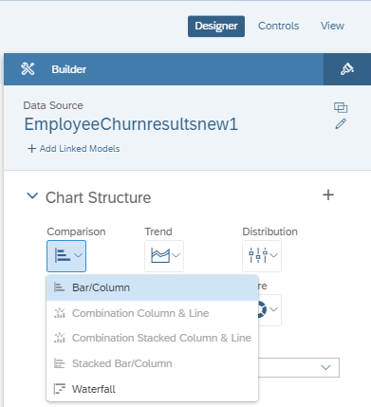

We select the Probability to churn as “measure”, the Age as “Dimension”, the Vertical orientation.

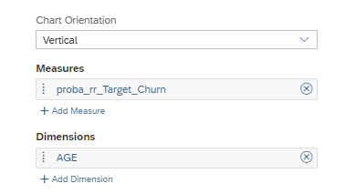

We can add an “input control” to filter the Age during the analysis

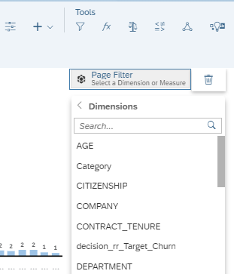

Then we select all members

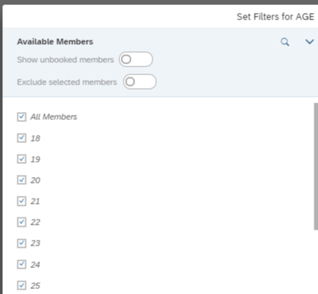

When this is done, we can resize the objects to make it easier to read. We can also edit the styling to put borders, choose colors, etc

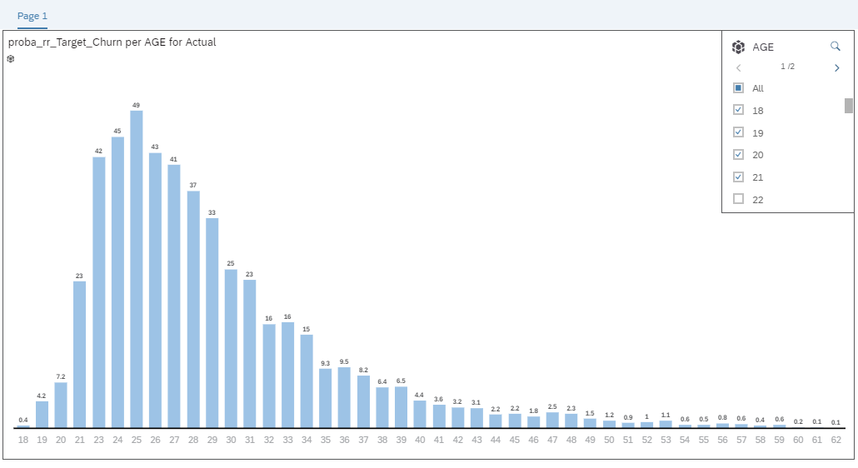

We will now add “Donuts” to expose churn by company, by Department, by Employee level, etc. We select “Insert Chart”, then “More” and “Donut” in the Chart Structure of the Design Panel

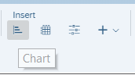 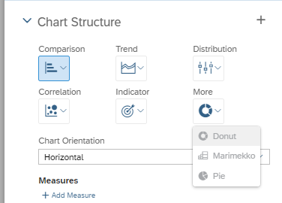

Choose the Probability to Churn “Measure” and the Company “Dimension”

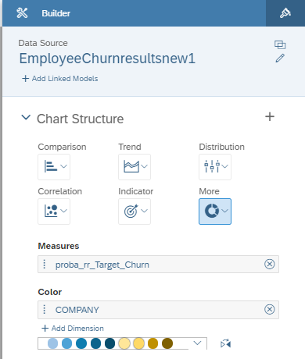

We choose Styling to can add a border

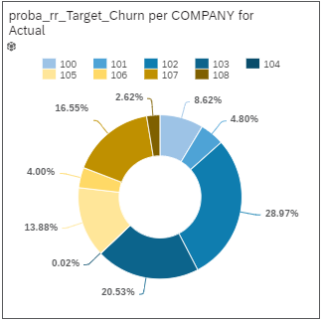

We can now duplicate the Donut

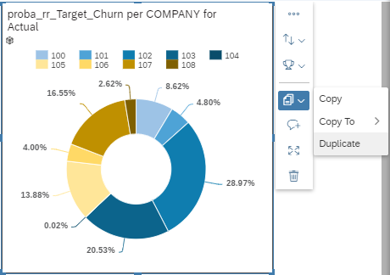

Remove the “Dimension” Company

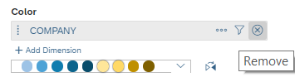

And add the “Dimension” Department

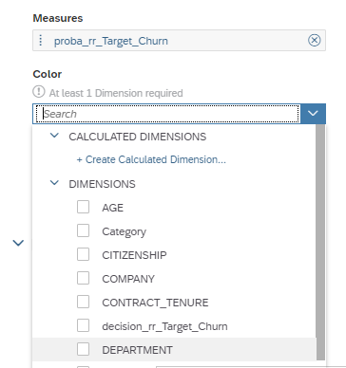

We can now add other “Input controls”, like Gender, to filter our charts

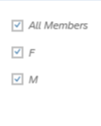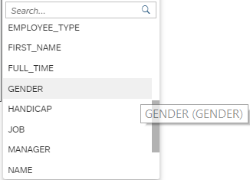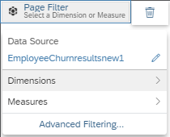

We can now create a table to show the employees. In the bar chart, we select “Insert Table”

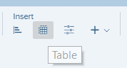

We will now choose and organize the columns we want to show

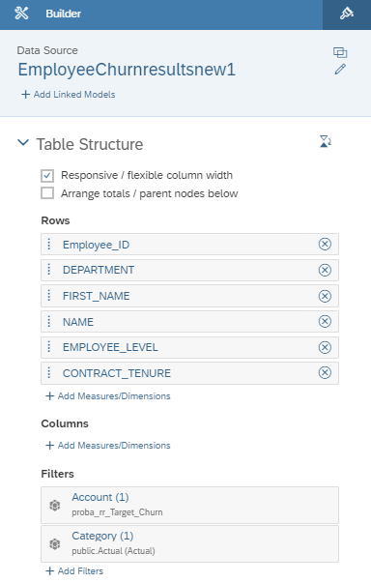

and display the table, including the risk of Churn for every employee

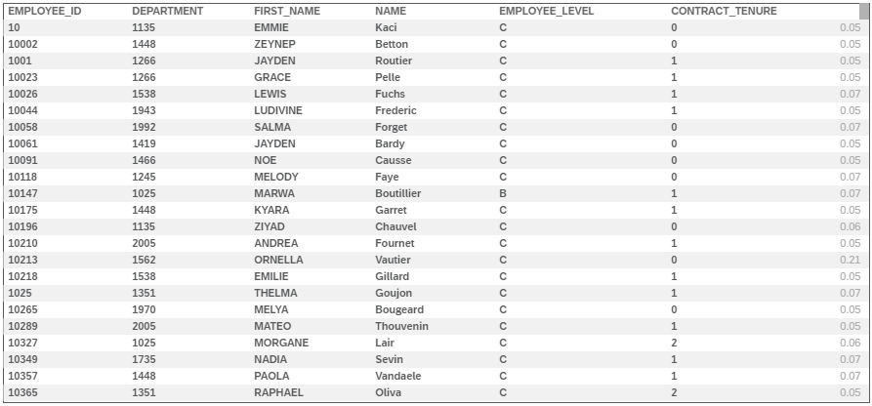

We can give a name to the page and arrange it as we prefer

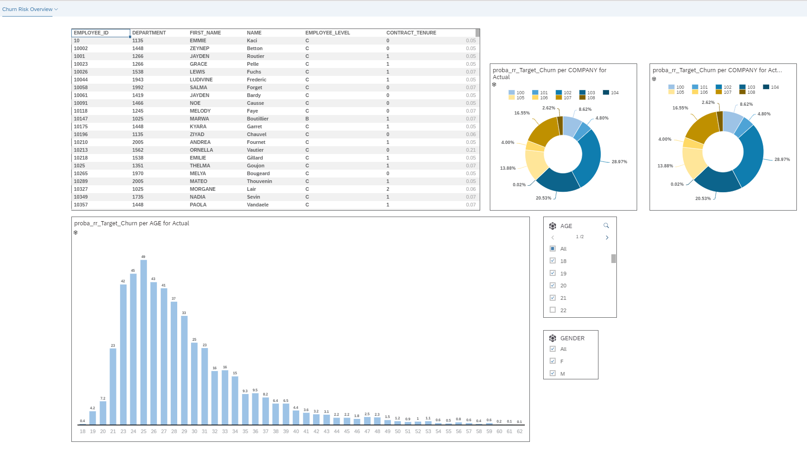

Be creative and add the company logo or adjust the styling to the company’s corporate identity, add more data, nice charts or a RSS feed. Just try it out.

The official SAP analytics Cloud tutorial and the playlist are very helpful.

<https://wiki.scn.sap.com/wiki/display/BOC/SAP+Analytics+Cloud+-+Official+Product+Tutorials>

<https://www.youtube.com/playlist?list=PLs5htBIwERYWSixKSqQHzndop33aBCz1U>

Have fun with doing your own predictions and building nice dashboards